

HR EMPLOYEE
ATTRITION ANALYSIS

PROJECT OVERVIEW
This project analyzes employee attrition to identify key factors associated with employees leaving the organization. The dashboard provides a comprehensive view of workforce characteristics, attrition trends, and department & role level insights to support data-driven HR decisions.

DATASET : IBM HR Analytics Employee Attrition & Performance.
TOTAL RECORDS : 1470 Employees
TOTAL FIELDS : 35 Columns

DATASET OVERVIEW
SOURCE: Kaggle
DATASET: IBM HR Analytics Employee Attrition & Performance
RECORDS: 1,470 employees
FEATURES: 35 columns
TARGET VARIABLE: Attrition (Yes/No)

DATA PREPARATION STEPS
- Removed duplicate records
- Handled missing values
- Standardized data formats
- Corrected inconsistent values
- Cleaned categorical fields
- Prepared data for analysis using Excel Tables

IMPORTANT FIELDS USED
- Employee ID
- Age
- Department
- JobRole
- Attrition
- Business Travel
- OverTime
- MonthlyIncome
- Years At Company
- Job Satisfaction
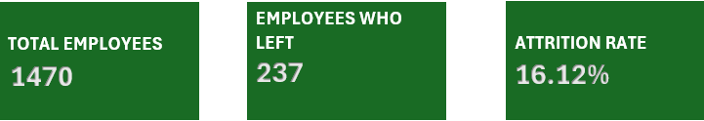
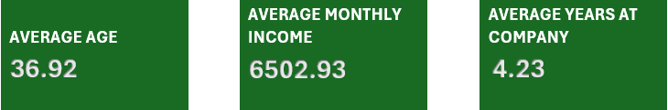
DASHBOARD OVERVIEW
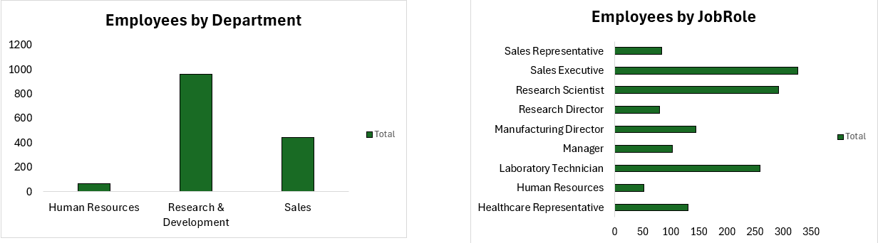
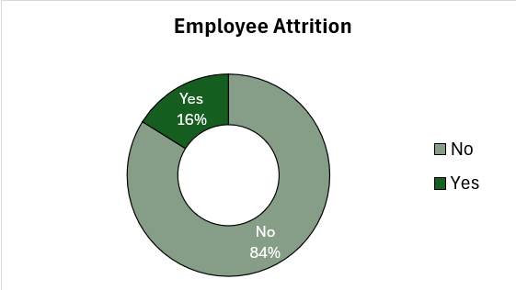
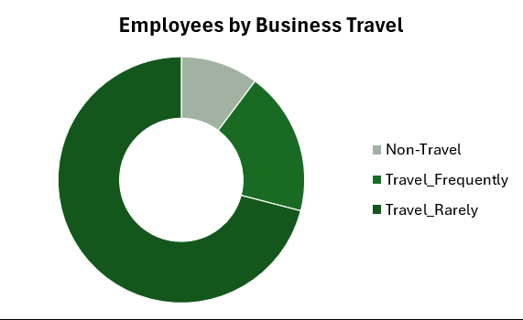
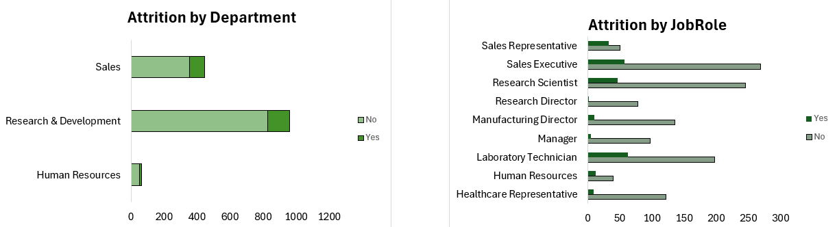

KEY INSIGHTS
IMPOTANT TAKEAWAYS FROM THE ANALYSIS.

- Research & Development has the highest number of employees, followed by Sales.
- Overall Attrition rate is 16.12% , meaning 237 employees have left the organization.
- Sales executive and Research Scientist roles have higher attrition compared to other roles.
- Most employees travel rarely for business. Non travel group is smallest.
- OverTime has a noticeable impact on attrition. Employees working overtime are more likely to leave.
- The dashboard helps identify departments and roles that may require retention-focused strategies.

SKILLS AND TOOLS USED

EXCEL SKILLS USED
- Data cleaning and preparation
- Excel tables
- Formulas and Functions
- PivotTables
- PivotCharts
- KPI Design
- Dashboard Design
- Data Analysis
- Conditional Formatting
- Data Visualization

TECHNIQUES APPLIED
Data cleaning : Removed duplicates , handled missing values, standardized data.
Data Modeling : Used structured tables and relationships with pivot summarization.
Exploratory Analysis : Explored workforce distribution and attrition patterns.
Dashboard Creation: Created interactive charts and KPIs for better insights.
Insights Generation : Derived actionable insights to support HR decision-making.

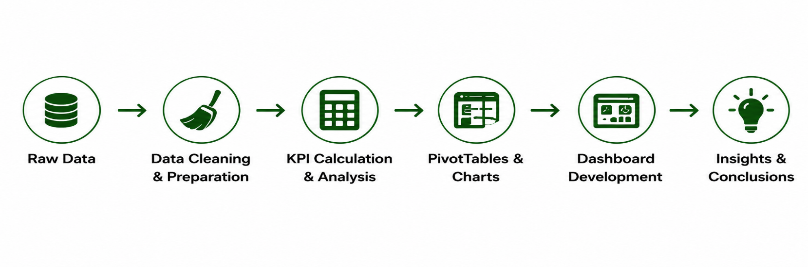
PROJECT WORKFLOW

PROJECT IMPACT
- Provides a clear understanding of employee attrition trends.
- Helps HR teams identify key factors influencing attrition.
- Supports data-driven retention strategies and workforce planning.
- Enables monitoring of KPIs and workforce health in real-time.

